PATTERN MATCHING

AIM: To implement a prolog program for Pattern Matching.

OBJECTIVES:
- To implement pattern matching in Prolog by comparing two lists and determining whether their elements match.

ALGORITHM:
- Take two lists as input.
- Compare their first elements.
- If they match, continue with the remaining elements.
- Continue recursively until both lists are empty.
- If all elements match, return true.
- Otherwise, return false.

SYSTEM-ARCHITECTURE:
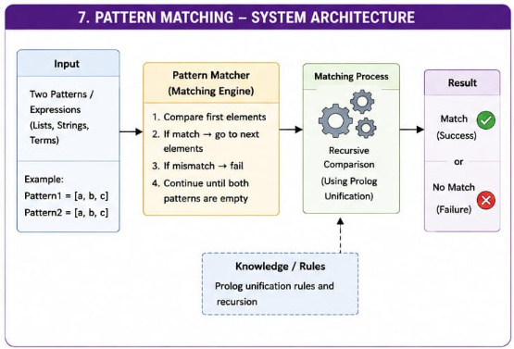

PROGRAM:
% Pattern Matching

pattern_match([], []).

pattern_match([X|Xs], [X|Ys]) :-
pattern_match(Xs, Ys).

OUTPUT:
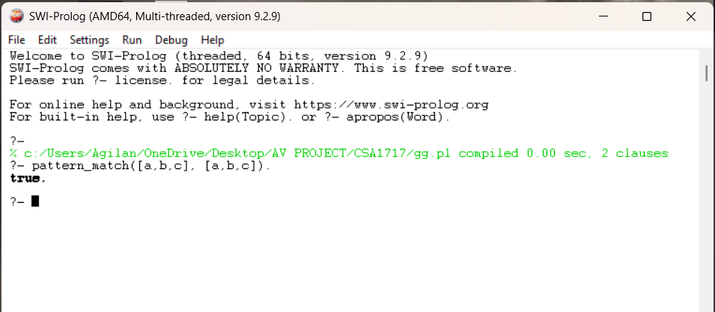

RESULT: Thus the Pattern Matching is implemented successfully using Prolog program.

